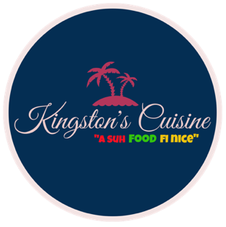

Kingston’s Cuisine
15 Catherwood Road, Ithaca, NY
Email: kingstonscuisine@gmail.com
607- 279-1163

Kingston’s Cuisine offers three (3) different catering styles. The following are;
- Traditional style (ask for details)
- Drop-off style (Free delivery for orders $500+)
- Buffet style (Extra $150 for set up)

Main dishes

Item | Price
Item | ½ hotel pan (serves 8-10 persons) | Full hotel pan (16-20 persons)
Rasta Pasta  (chicken, shrimp & vegan options available) | $200 | $400
Jerk Wings | $70 | $140
Barbi Fry Wing | $70 | $140
Chicken Tenders | $60 | $120
Reggae salad | $125 | $250
Cajun Pasta  (chicken,shrimp & vegan options available) | $200 | $400
Jerk Chicken | $175 | $350
Fried chicken | $150 | $300
Barbi- fry chicken | $150 | $300
Curry chicken | $170 | $340
Stew chicken | $150 | $300

Sides

Item | Price
Item | ½ hotel pan (serves 20 persons) | Full hotel pan (40 persons)
Rice and peas | $ 60 | $120
White rice | $40 | $80
Fried Plantain | $80 | $160
Garlic and herb mashed potatoes | $40 | $80
Baked Mac n cheese | $50 | $100
Potato Salas | $50 | $100
Fried dumplings | $130 | $250
Spring Rolls | $130 | $250
French fries | $90 | $180

Additional detail that affect catering prices;
- Add-on menu items
- Staff and supplies
- Driving distance
- Event date (holidays)
- Extra time

